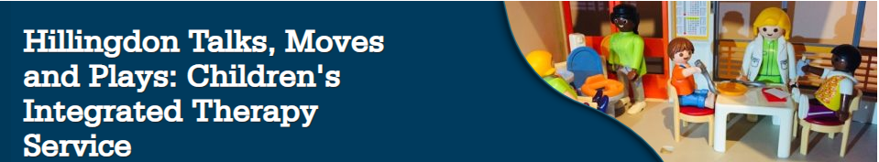

Children’s Integrated Therapy Service (CITS)
Speech and Language Therapy, Physiotherapy and Occupational Therapy
CITS Advice Line: 01895 488 200

CITs - www.cnwl.nhs.uk/hillingdon-talks-moves-plays
Speech and Language Therapy - https://www.cnwl.nhs.uk/services/community-services/hillingdon-talks
Physiotherapy - https://www.cnwl.nhs.uk/services/community-services/hillingdon-moves
Occupational Therapy - https://www.cnwl.nhs.uk/services/community-services/hillingdon-plays

There is regularly updated information and support for parent/carer(s), education staff and professionals. This includes videos, advice sheets, strategies and resources and links to other useful websites and local services.

We also have Social Media:
 | @HillingdonTalks | @HillingdonMoves | @HillingdonPlays
 | @Hillingdon_TalksMovesPlays
 |  |  | @HillingdonPlays

